**How to Edit the Document**

1. Editing of document is done through network drive mapping of E-Dokyumento SMB-shared drive.
2. When e-Dokyumento server is accessed within the LAN, map the network drive directly using the windows explorer. As much as possible use ‘Z’ as the drive letter.

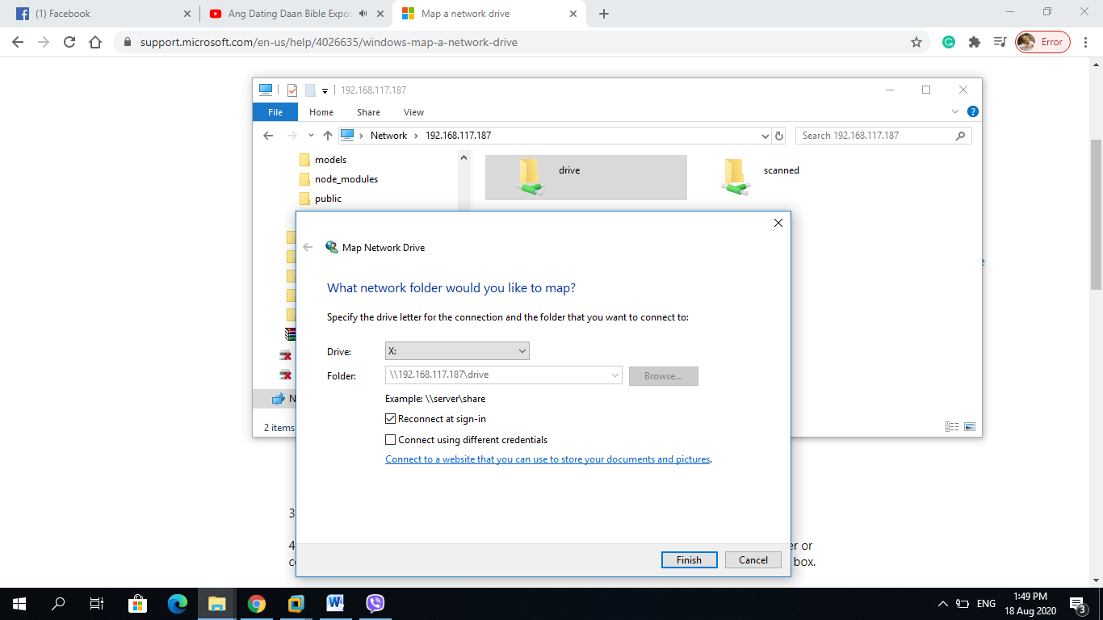

1. When remotely accessing the mapped drive over the Internet, apply one of the following options:
   1. Setup Virtual Private Network (VPN) access for the client through the Firewall.

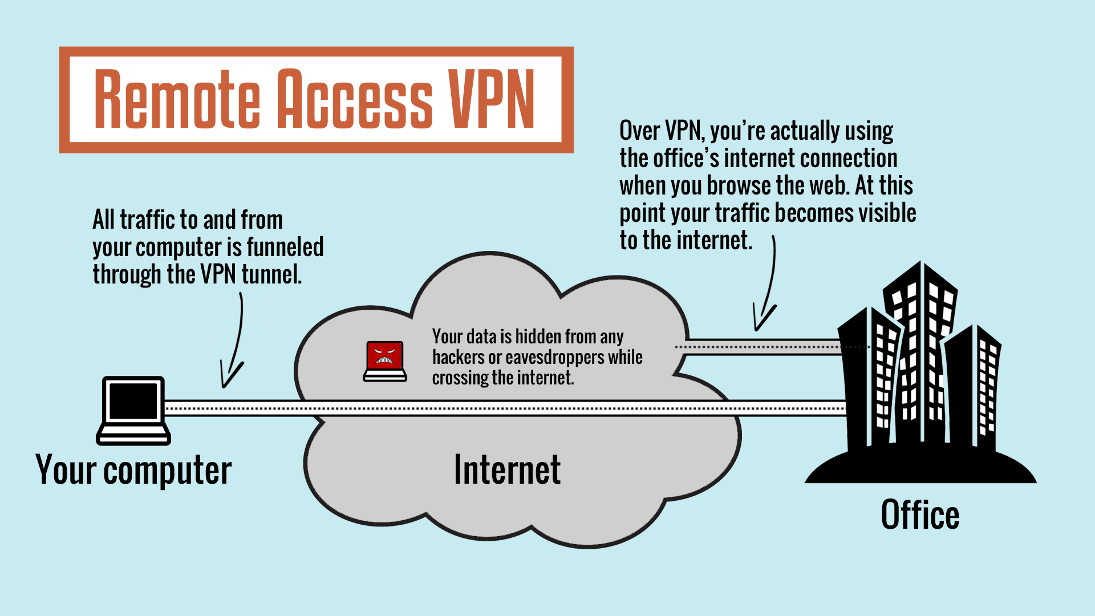

* 1. Port forwarding of TCP/UDP Port 139 and 445 from the Firewall.

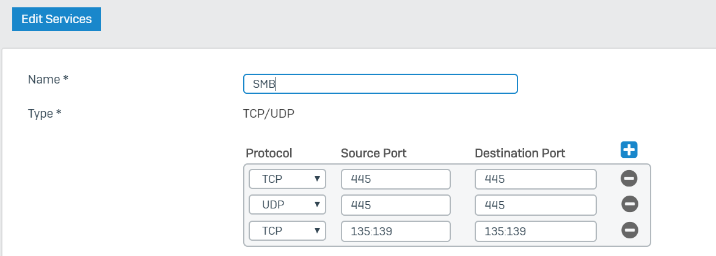

Note: The former is more secure than the latter.

1. When asked for username and password during mapping of SMB drive, use the default account - ‘nelson’ for the username and ‘maligro’ for the password.
2. Optionally, you can change the user and password through SMB configuration inside the e-Dokyumento server. Below is an example of the SMB Configuration:

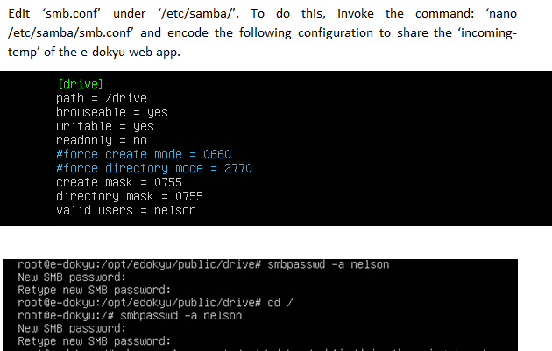

* 1. Ensure that user account ‘nelson’ is created in the server. Do this by invoking the command ‘useradd nelson’ then ‘passwd nelson’.
  2. Ensure that smb account ‘nelson’ is created in the server. Do this by invoking the command ‘smbpasswd –a nelson’.
  3. Ensure that the account ‘nelson’ owns the ‘drive’ folder. Do this by invoking the command ‘chown nelson:root /drive –R’

1. To allow opening of file through the browser, install the registry file from the ‘Doc\Tools’ Folder or you can download and install this file from <https://github.com/nelsonmaligro/e-Dokyumento/tree/master/docs/tools>.

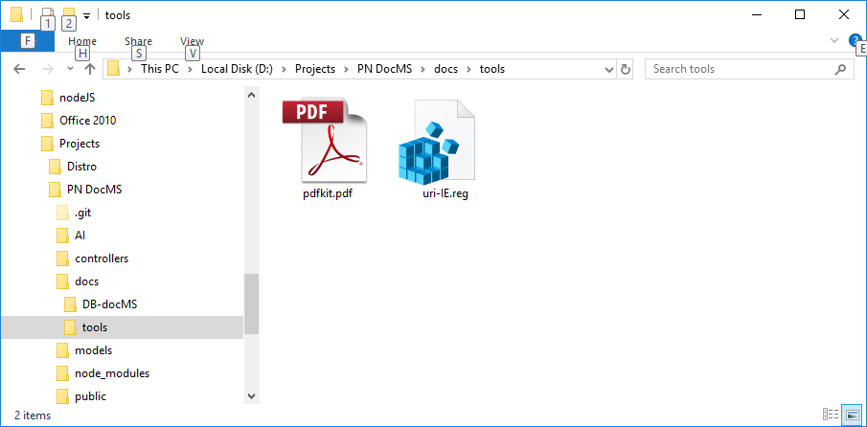

1. If the mapped drive letter is not ‘Z:’, then update the drive letter on the individual account through the e-Dokyu web app using the ‘administrator’ account.

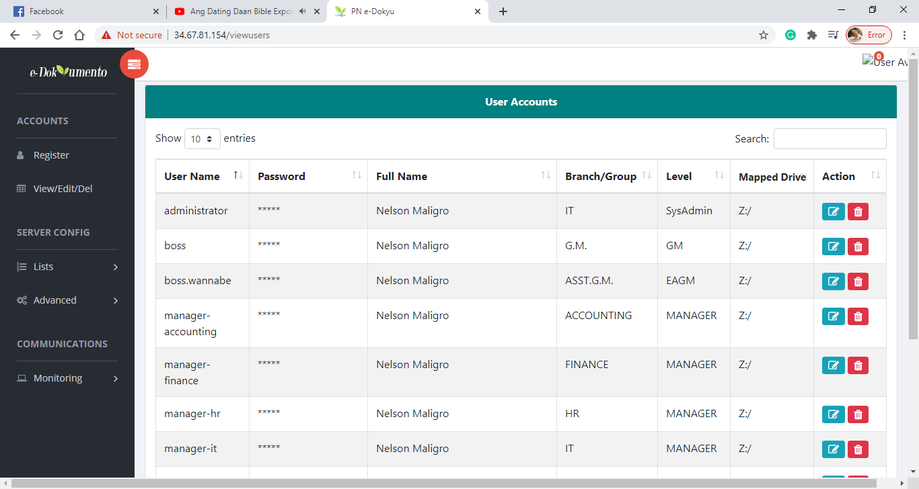

1. After successfully mapping the SMB drive, open e-Dokyumento web app and click the ‘check map drive’ to verify that the web browser has access to the map drive.

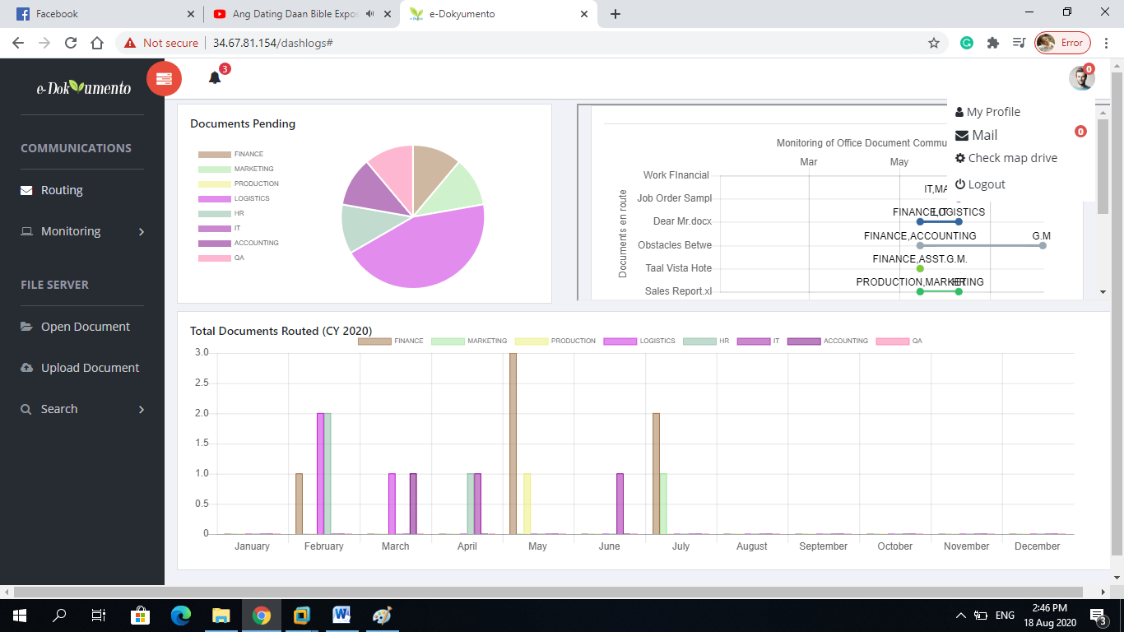

1. The popup window will appear. Click ‘Open Windows Command Processor’.

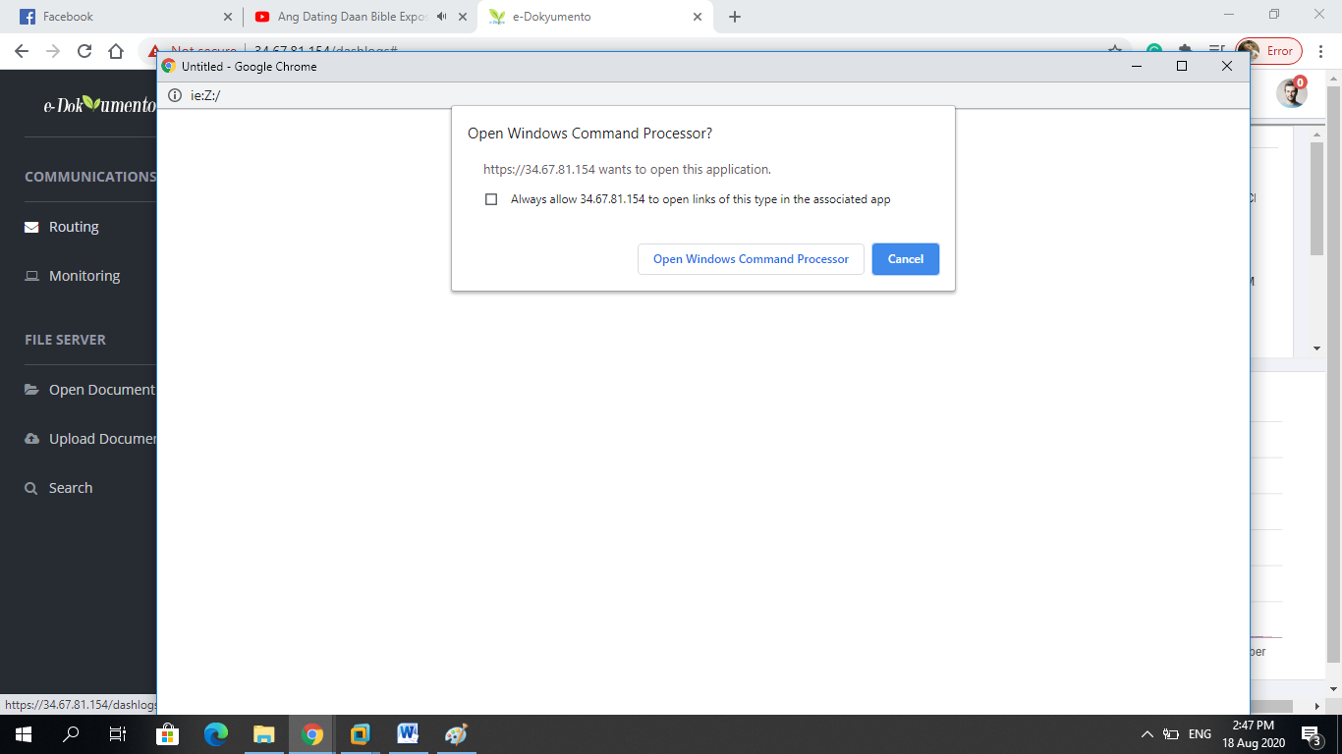

1. When asked to login, use the default account: ‘nelson’ for username and ‘maligro’ for password.
2. You can now edit the document. Open the document or select from the pending documents then click ‘action’, ‘Edit Document’.

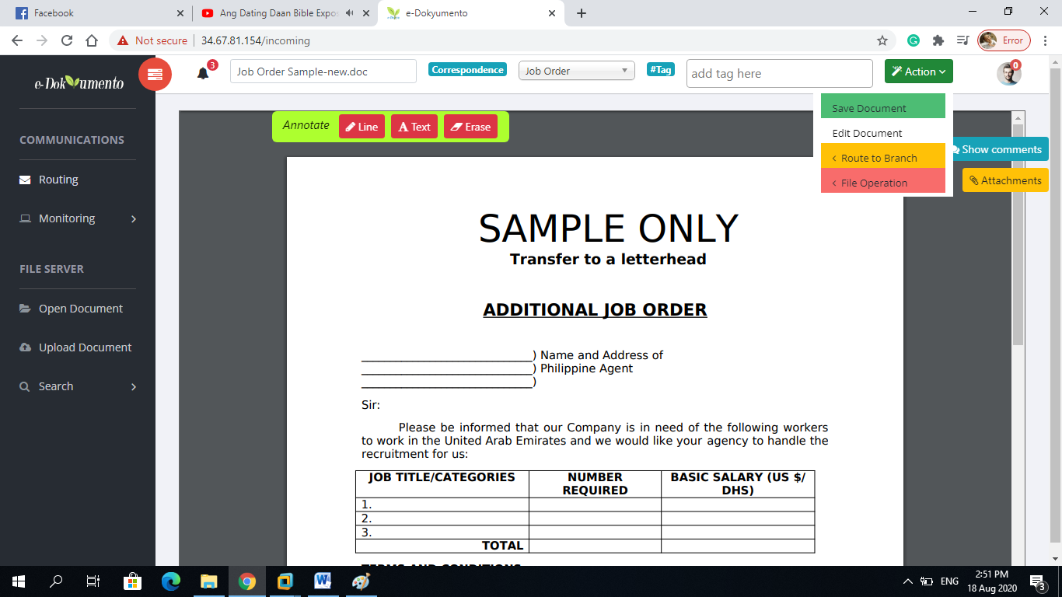

1. For non-Active Directory (AD) client, there may be a need to re-login on the map drive every time the computer restarts. To do this, repeat step 7 to step 9.